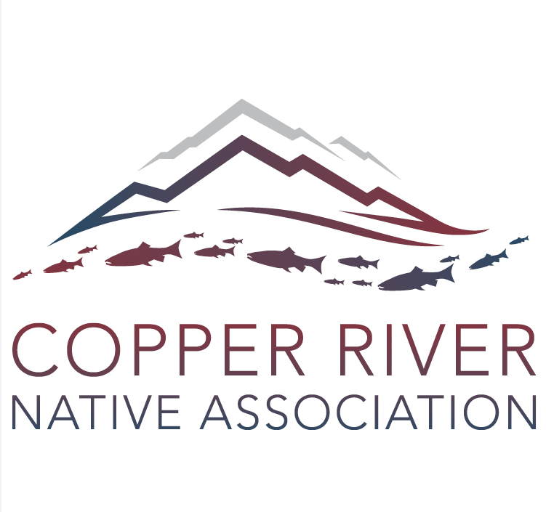
Application for Services
CLOTHING/ EMERGENCY GEAR/ PERSONAL HYGIENE

These programs are funded through the State of Alaska Community Initiative Matching Grant and its sole purpose is for people to have appropriate clothing, emergency gear and/or to receive personal hygiene products that support you or your families current need.

Eligible individuals must either be homeless and/or meet the income eligibility requirement to receive these services.

Contact Information
Head of Household Name:
Physical Address:
Mailing Address:
Phone No.:
Name | Size | Item | Date Distributed
If there are additional members please list on a blank sheet of paper and attach.

Participant’s signature: Date:

Self-Declaration of Need & Liability Release

By signing this form, I declare that I am:
In a household where the income falls at or below the posted Federal Poverty Level
The clothing, emergency gear or personal hygiene I receive today from Copper River Native Association will be used by me and/or my household and will not be sold or misused in any way. The clothing, emergency gear or personal hygiene items I receive today come from a variety of sources. I accept the clothing or personal hygiene items “as is” and release both the original donor and the pantry from any liabilities, damage, losses, claims, causes or actions and suites of law pertaining to the items I receive.
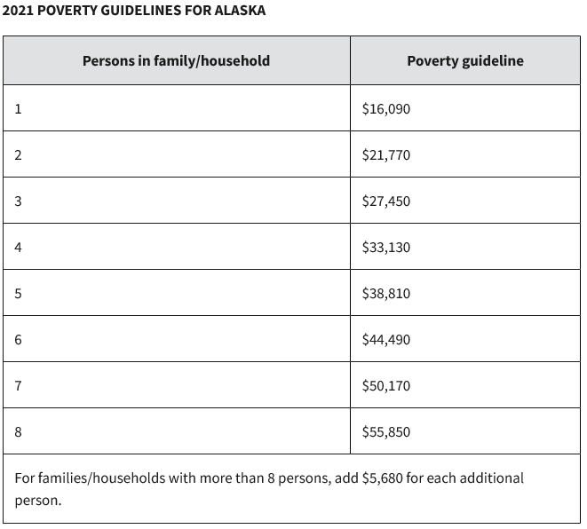

Participant’s signature: Date:
Agency signature: Date:

